BALLYMAHON MUNICIPAL DISTRICT

Corporate Affairs,
Aras an Chontae,
LONGFOIRT.

21st May 2015.

To: Each Member of Ballymahon Municipal District.

Dear Member,

You are requested to attend Meeting of Ballymahon Municipal District to be held in Ballymahon Library, on Thursday, 28th May 2015 at 4.00 p.m. to transact business, as set out on the Agenda hereunder.

Yours sincerely,
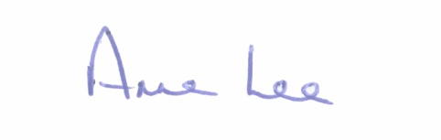

_______________
Anne Lee,
Meetings Administrator.

AGENDA

Prayer before meeting.

1. Confirmation of Minutes of Meetings of Ballymahon Municipal District held on the 26th March 2015 - copies enclosed.

2. Matters arising from Minutes.

3. Casual Trading in Ballymahon.

4. Safe Parking Options at Ballymahon Schools - Feasibility Study enclosed.

5. Consideration of report on Burial Grounds in the Ballymahon District.

6. Report on Notices of Motions - to follow.

7. (a) Consideration of the Taking in Charge of “Thomond Court Access
Road” Ballymahon, Co. Longford - details attached.
(b) Consideration of the Taking in Charge of “Auburn Park”
Edgeworthstown, Co. Longford - details attached.

8. Consideration of Part 8 – Manager’s Report in accordance with Section 179 of the Planning and Development Act 2000 ( as amended ): Part 8 of the Planning and Development Regulations 2001 ( as amended ) in respect of the provision of a shared pedestrian and cycle track along the Royal Canal towpath from Cloonsheerin Bridge in the Townland of Cloonsheerin, passing through various townlands to the County Boundary with Westmeath at Clonbrin for a distance of 28.2km - report to follow.

9. Notices of Motions submitted by Councillors, as listed hereunder -

Councillor Paul Ross.

“That Longford County Council seeks funding from the NRA to upgrade the N55 from Edgeworthstown to Ballymahon to facilitate the increased traffic in light of the Centerparcs development.”

“That metal barriers that were previously in situ be replaced on the Whitworth Aquaduct road at Drumanure, Abbeyshrule in the interest of public safety .”

“That the footpaths on Church St, Edgeworthstown be upgraded and replaced.”

10. A.O.B.

